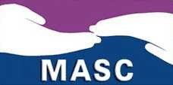
Dauphin Senior Centre
&
Manitoba Association of Senior Centres in partnership with the R.C.M.P.
present
POLICE ACADEMY: OLDER ADULT DIVISION
7 week FREE program Wednesdays February 19—April 1 1:15—3:30 p.m.
Topics include Mature Driver,
Safe Medication Use, Will and Estates, Safe Banking and more!
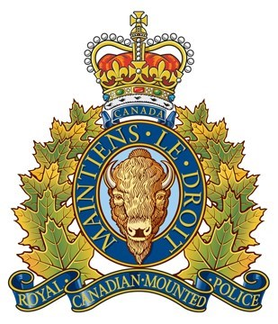
We invite former graduates to attend.
Limited seating, please Pre-Register at 204-638-6485.

